**23. AWS-Database- RDS**

**MYSQL DATA BASE CREATING**

--- you cannot see the instance in AWS EC2 but you can see this instance in NETWORK INTERFACE

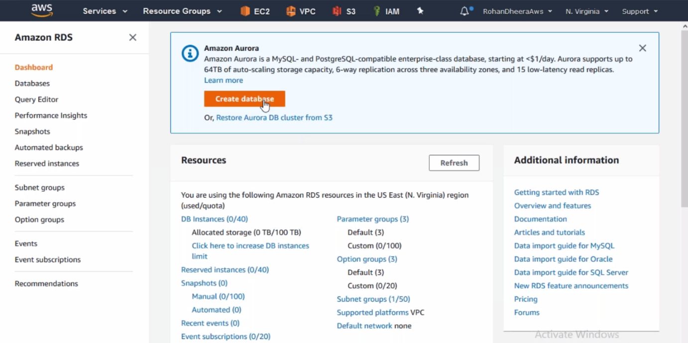

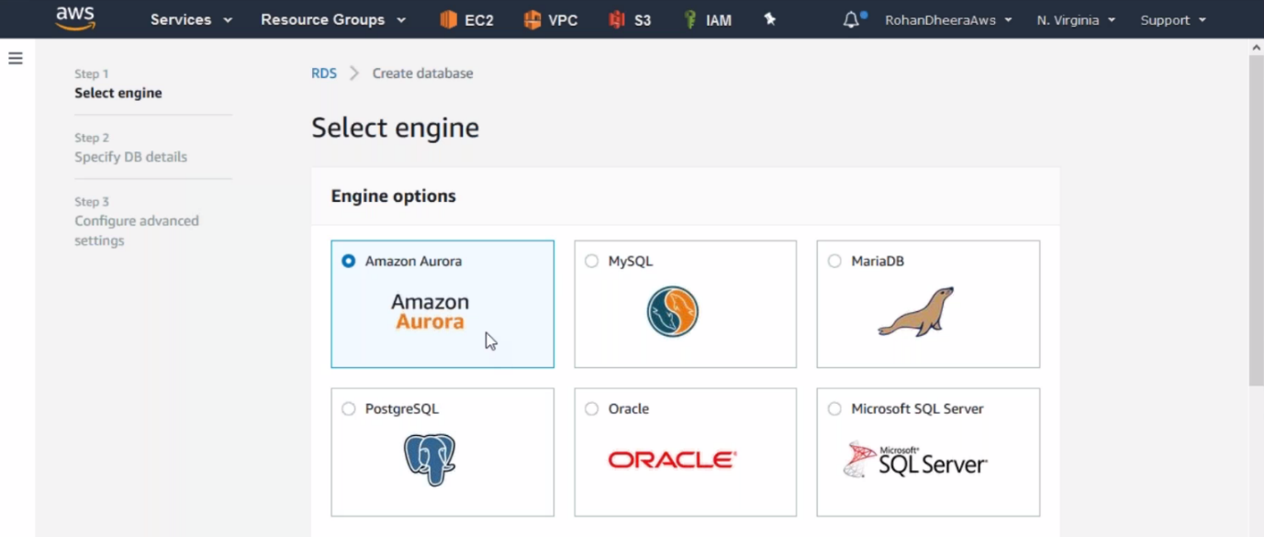

--- Select MySQL

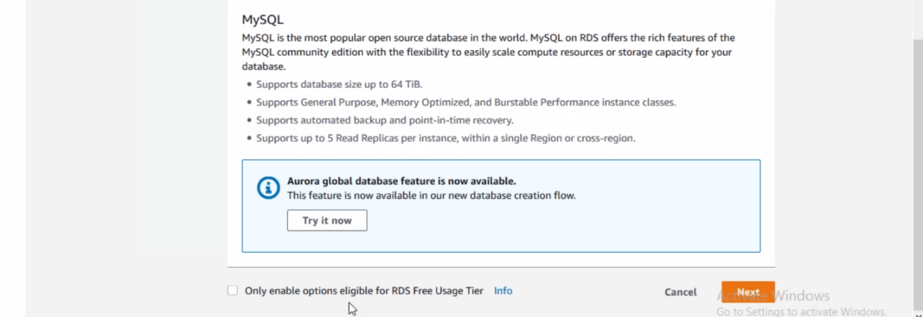

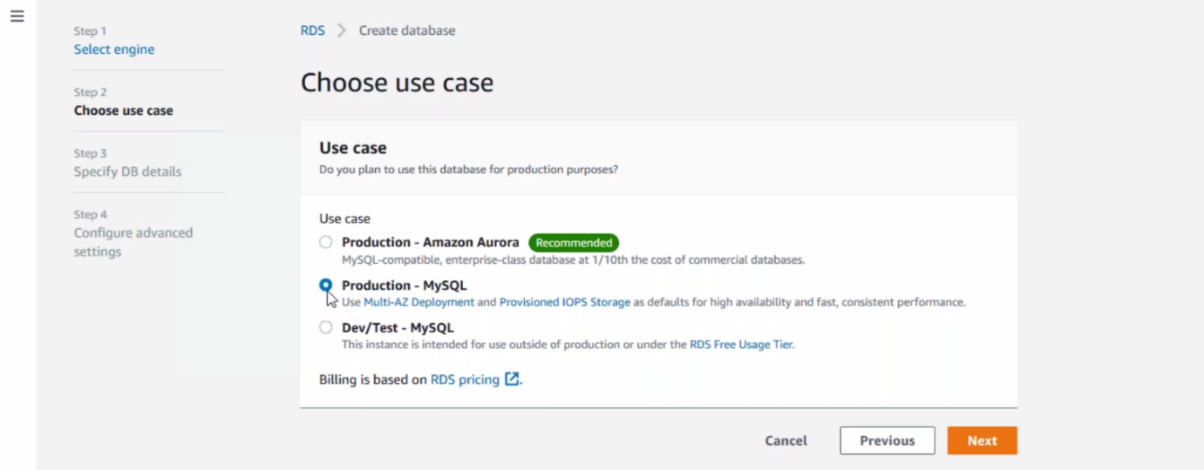

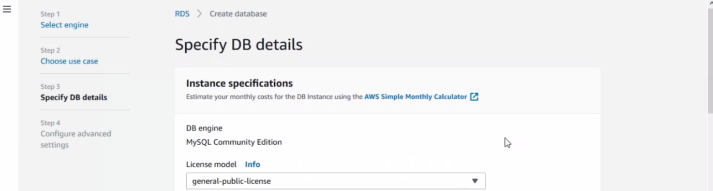

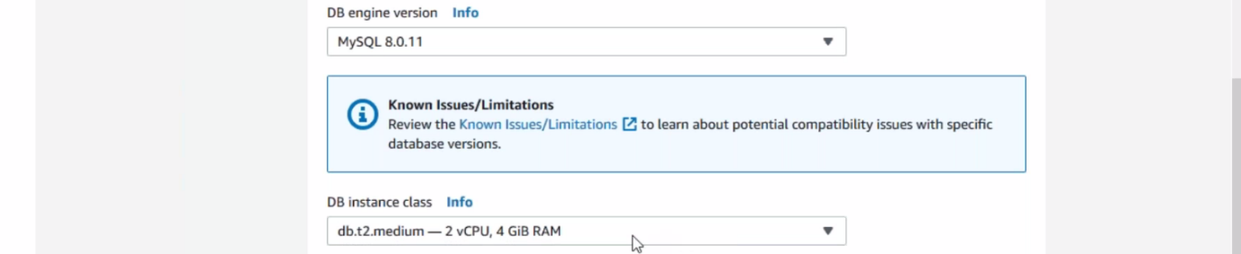

--- here the instance is maintained by AWS. You cannot see this instance in AWS EC2 option. You can also use t2 small for low cost

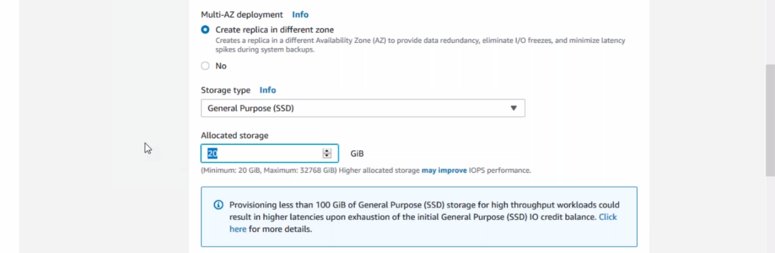

--- extra replica will created in different zone so if one availability zone down other one is used.

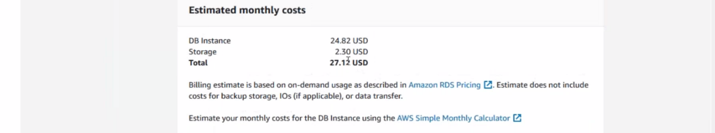

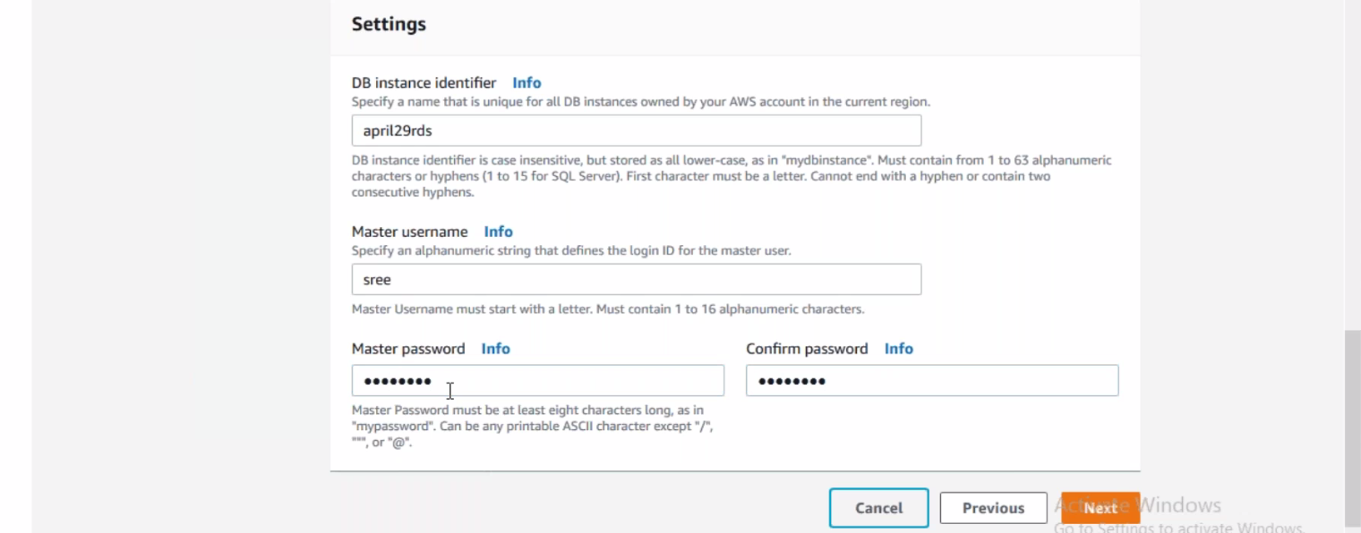

--- give data base name.

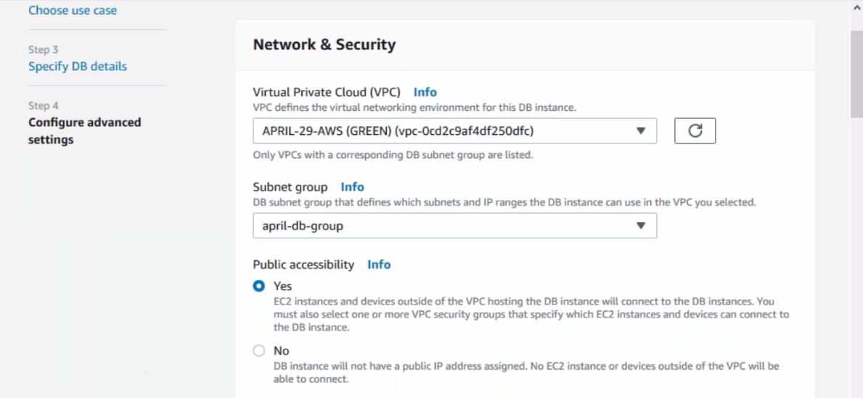

--- in real time we don’t give public accessibility to data base, because we don’t connect the data base over the internet. We gave yes but here we are doing for testing purpose so give NO.

--- you are deploying in multiple availability zones so need to create subnets. You want to create subnets manually go back to subnets

--- primary data base will created in 1 zone and replica will created in other zone so that is we need to subnets

**Creating subnet’s manually**

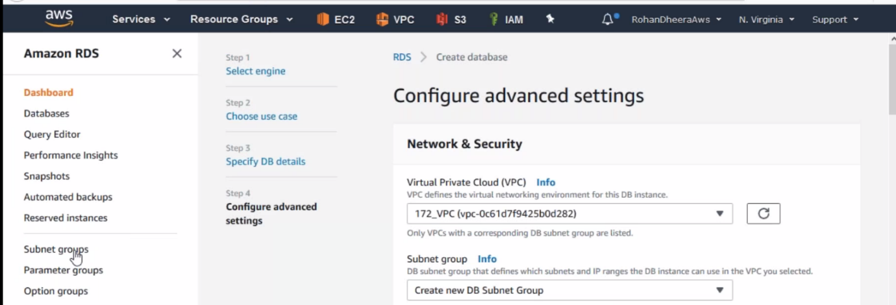

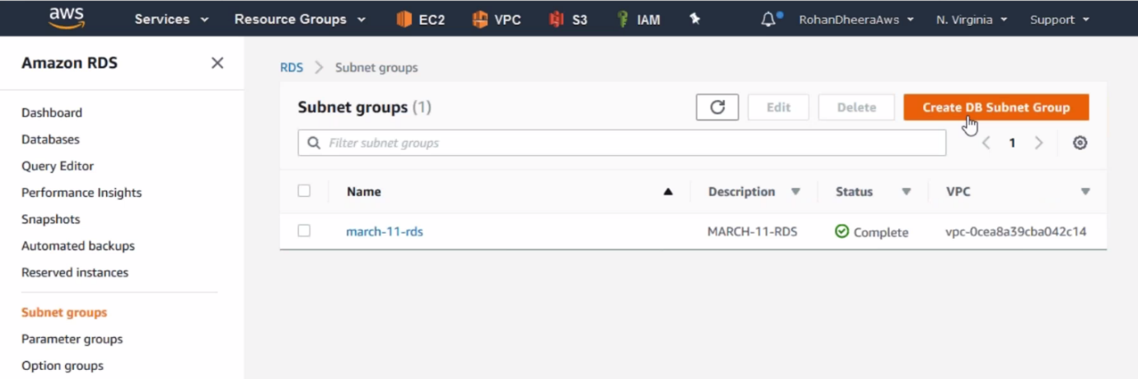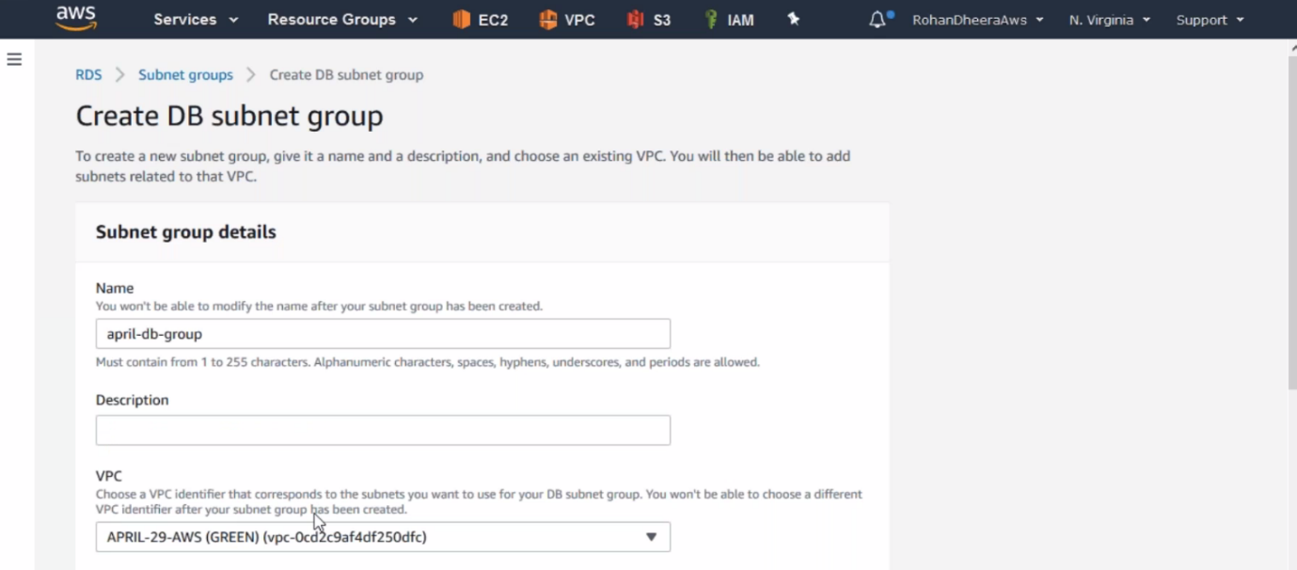

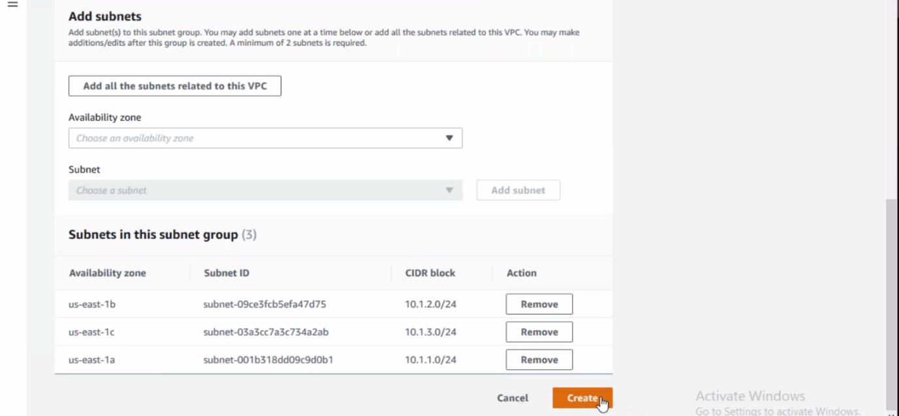

OVER

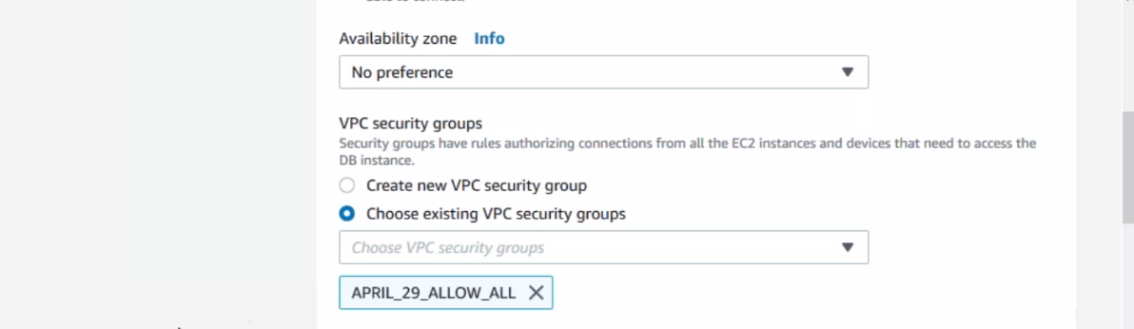

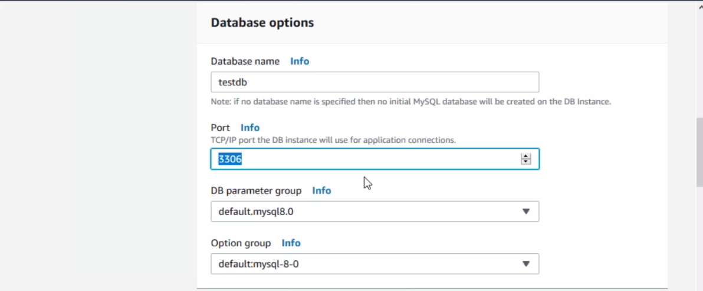

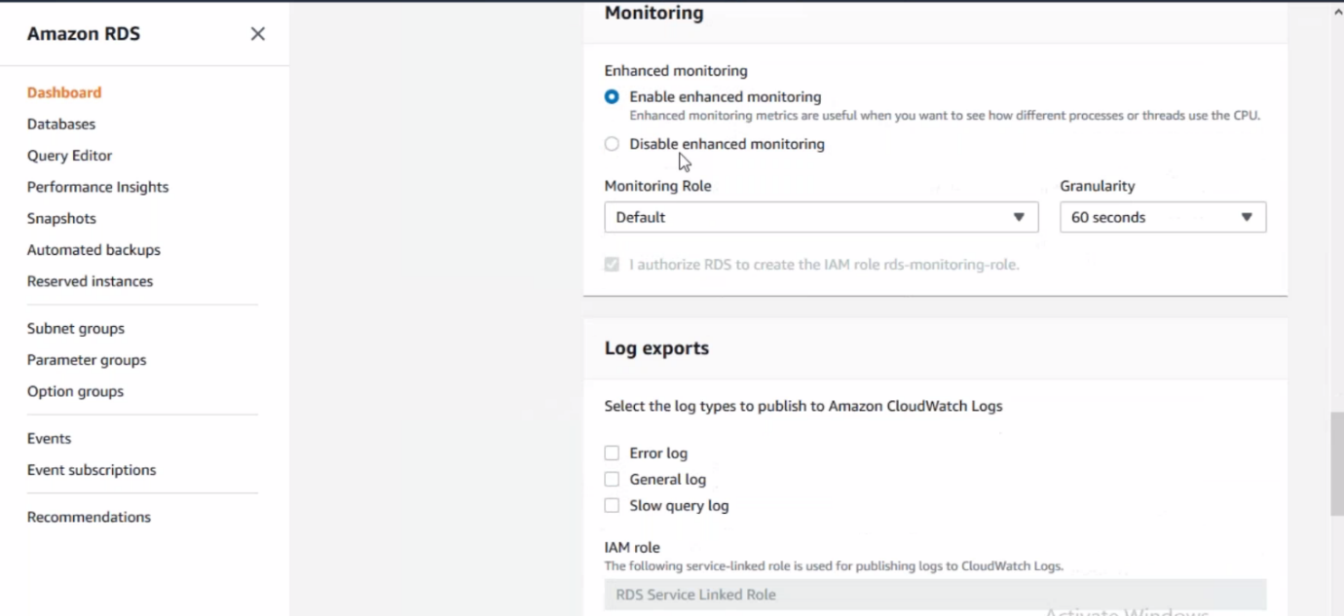

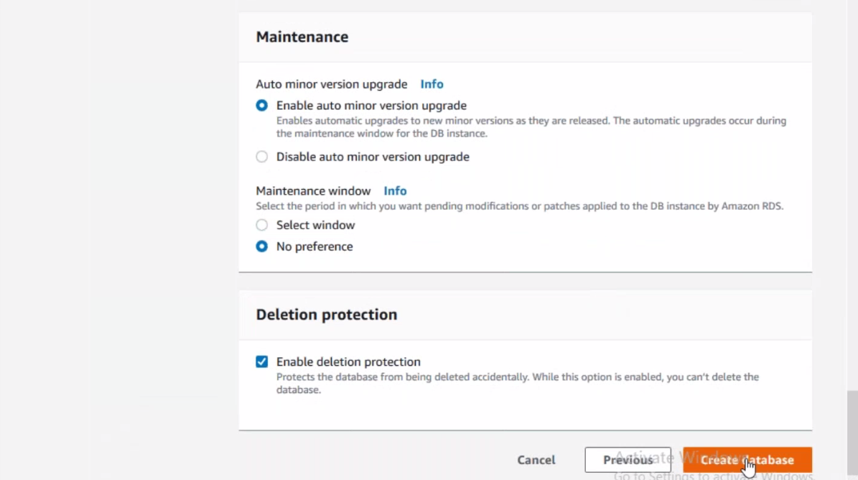

**MySQL Data base working**

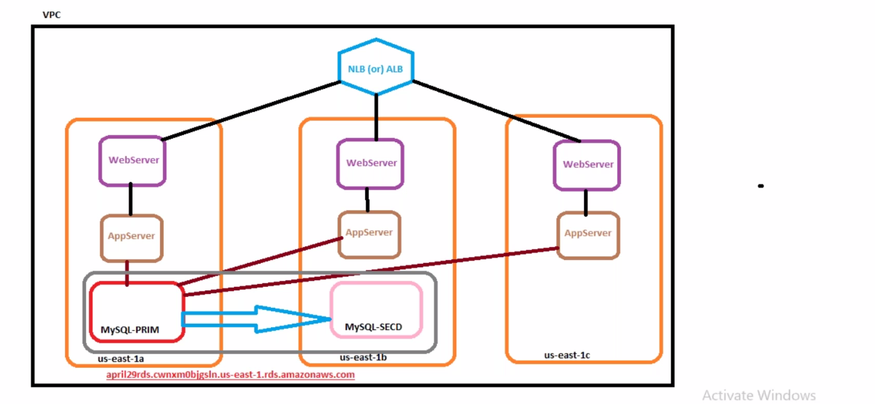

After creation of data base the main DB present in 1 zone and replica will present in other zone. All app servers connected to main data base. If the main data base is failed then app servers are connected to replica. Here if the we write some data in main DB then later that data copied to replica DB

--- **QUES How the application server knows that if the main DB failed it needed to connect to replica or secondary DB…?**

We connect manually to secondary or the primary and secondary will be in same group and connected to same endpoint

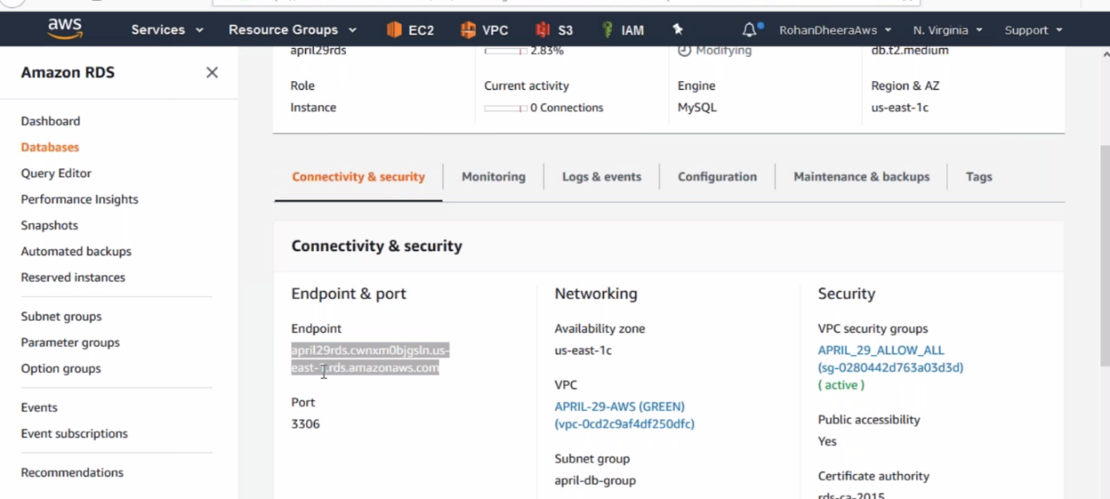

**MySQL Work bench**

You want to connect the created MySQL DB need download MySQL Work bench

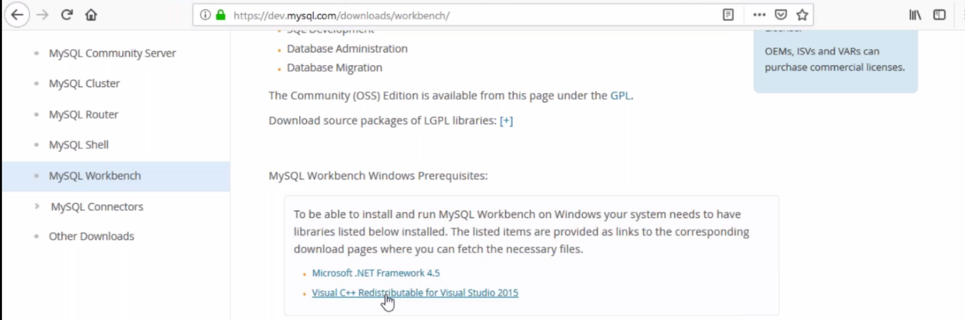

--- you are using windows XP, windows7 need to install Micerosoft.net Framework 4.5 or if you using windows 10 download 2nd one.

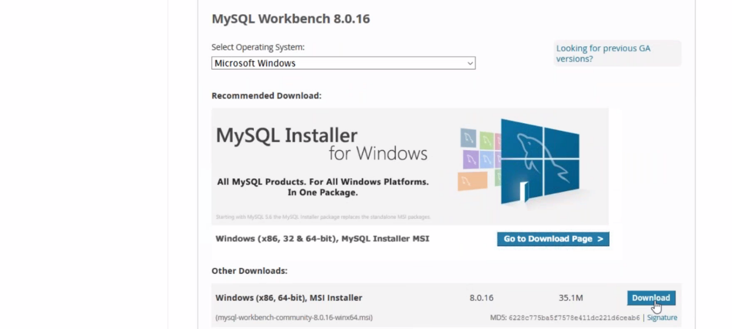

**Connecting to MySQL DB using MySQL work bench**

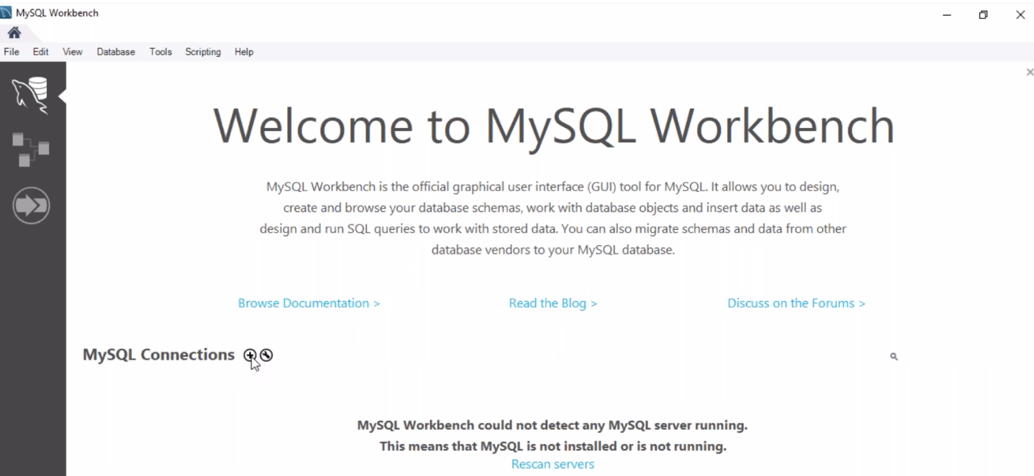

--- click on MYSQL connections

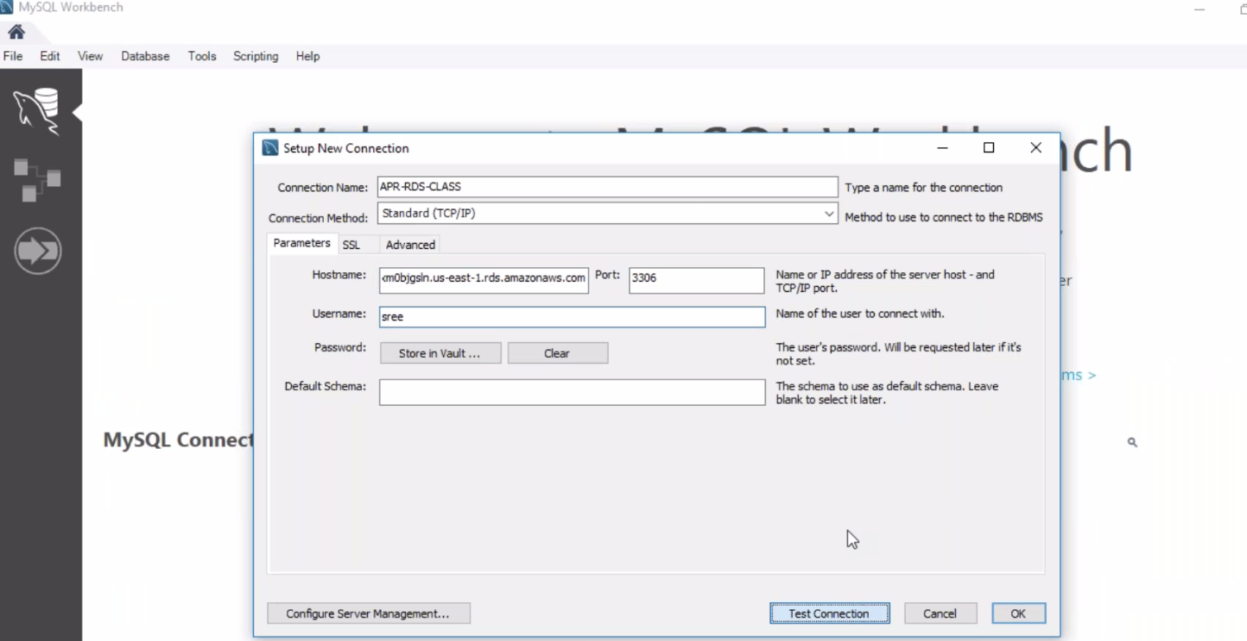

--- host name is = end point name

--- click on Test connection. It will ask you for password then enter password

--- connection successful.

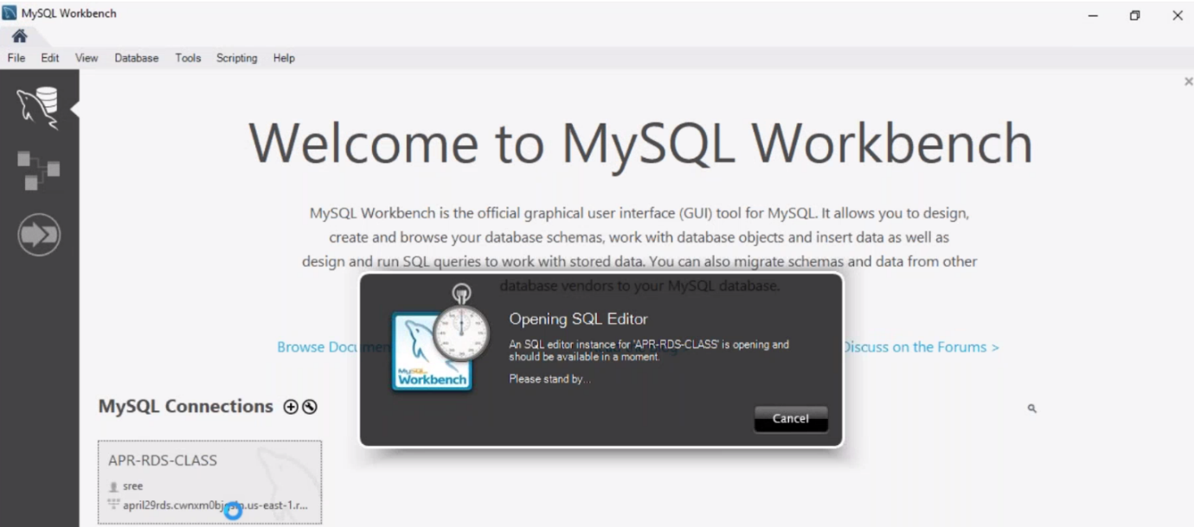

--- doble click on connection and it will open.

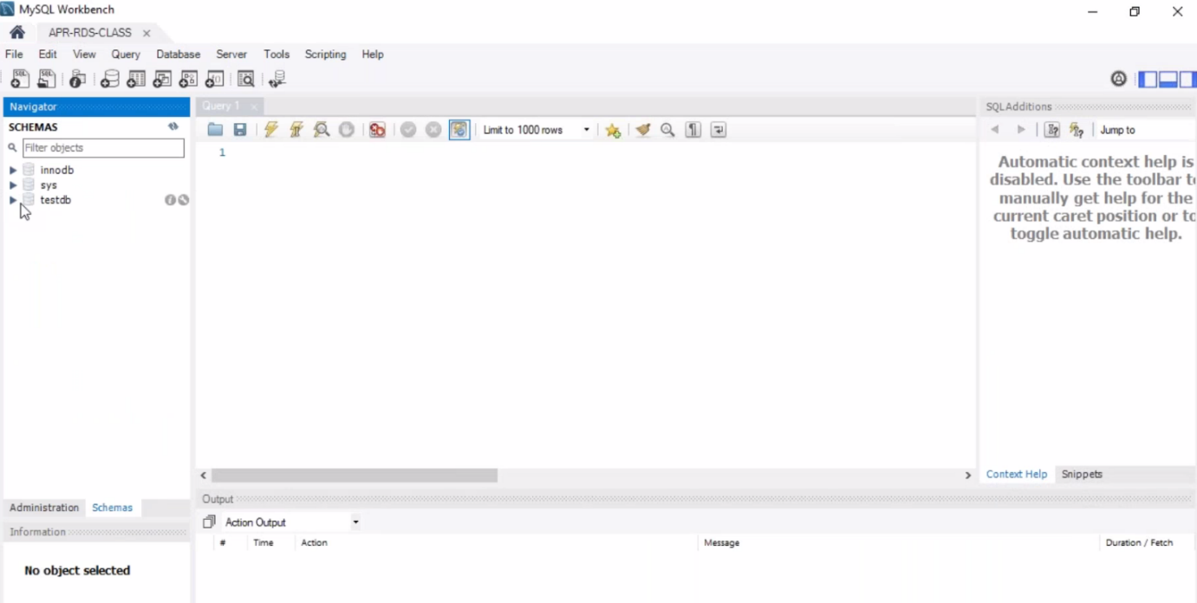

--- click on Schemas and you will find **test DB.**

**Backup for MySQL DB**

We can have maximum backup time up to 35 days

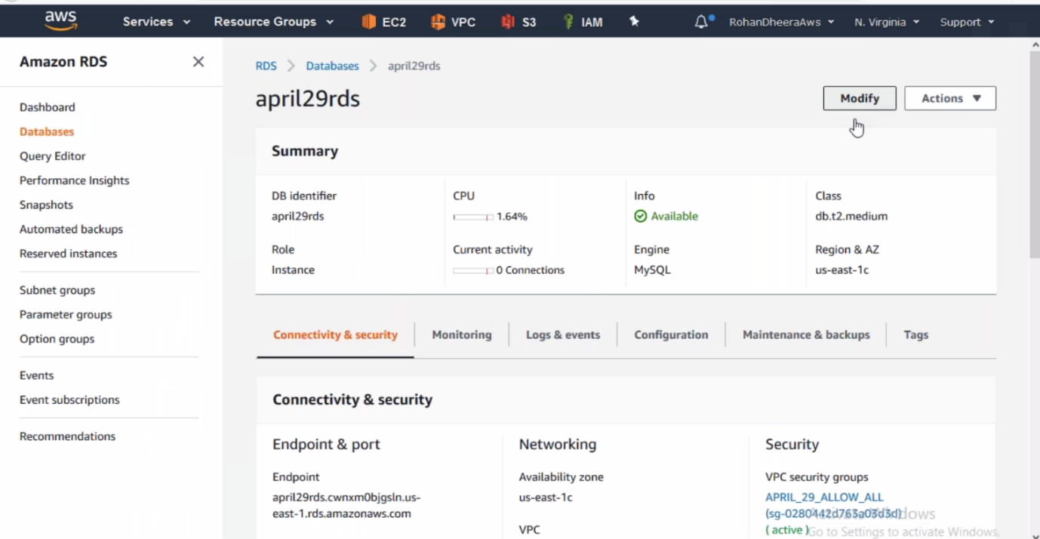

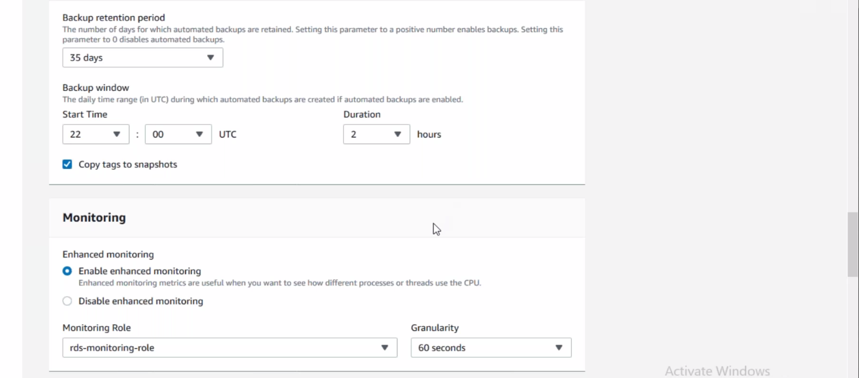

**Snapshot for MySQL DB**

We can take back up or we can also take snapshot

If you take snapshot manually then AWS would not delete this snapshot’s we delete them manually so this is why we take backups for maximum times.

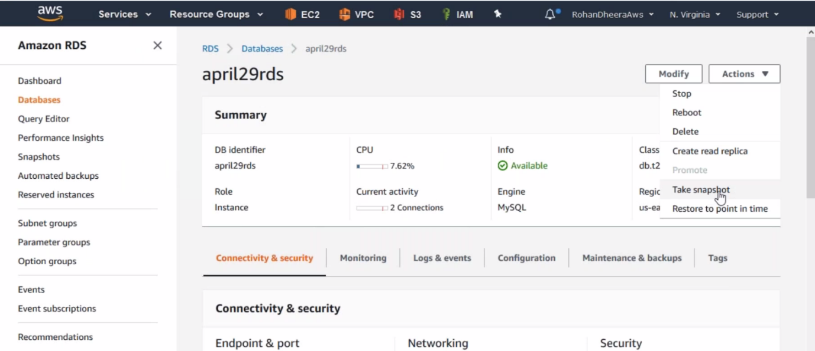

**Creating replica from DB**

We can create maximum 5 Replicas from an instance

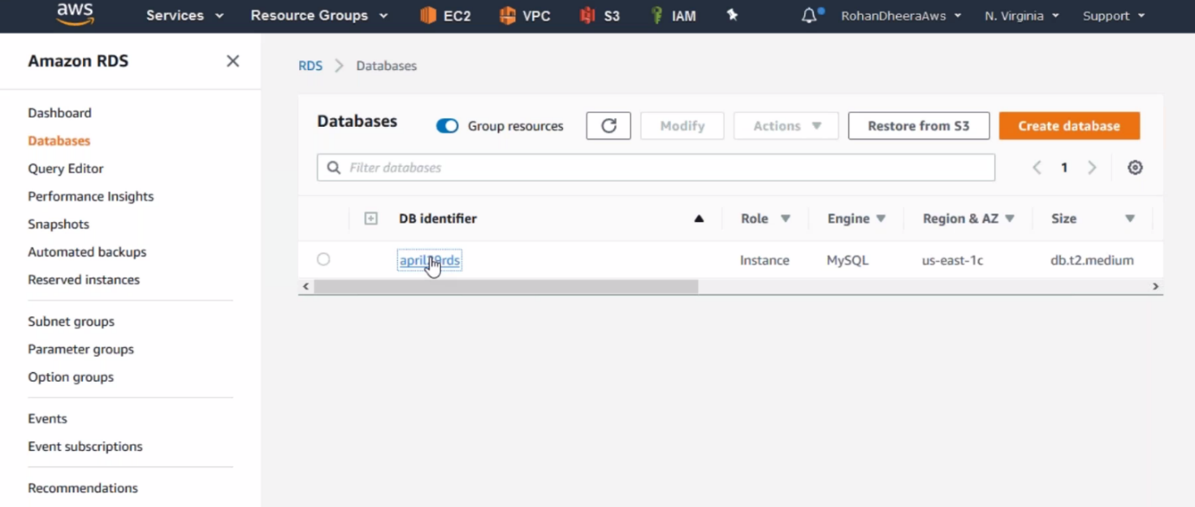

--- click on DB

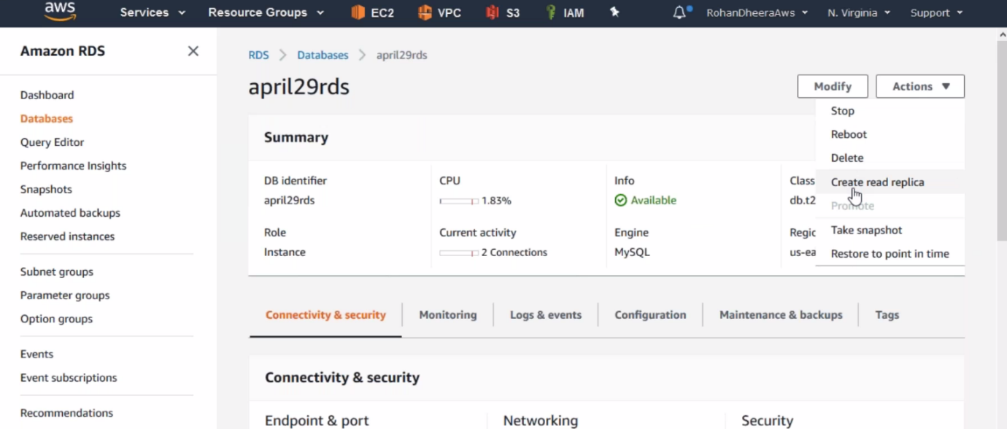

--- The process is same as creating a DB.

**Data pipe line**

By using, this feature we can move RDS MySQL data base to the S3

